**Requirement:**

Ownership of everything the project produces must be clearly defined and documented. For example, through copyright, trademark or other publicly available information.

**Approach taken for development of Aajeevika:**

UNDP contract clearly mentions- "UNDP retains ownership and Intellectual

Property (IP) rights to use the software globally."

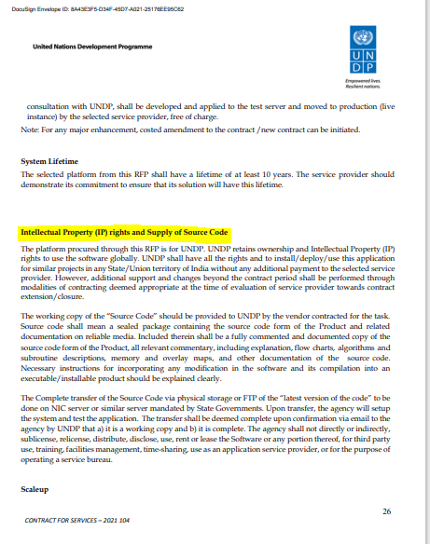

The source and associated documentation is available on github (https://github.com/UNDPIndia/Aajeevika)

